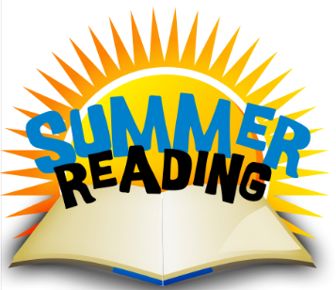
Rising 6th – 8th Graders Summer Reading Guidelines 2016
Goal: Read 20 hours this summer and log your hours on the form provided by the Knox County Library.
Bring completed form to your local library by July 15, 2016 for great prizes. Request to keep the form!!
Bring this same completed form back to school by Monday, August 14, 2016 for a reward. This will count as you first homework grade for Language Arts.
What do I read? Read books off the suggested list provided by school, books of your choice that are age appropriate, or books off the suggested Knox County Library list. (The suggested school list is included in this packet, however it is printed in small print. The full-sized, complete list is included on the Middle School Main Language Arts webpage: http://sjsmiddleschool.weebly.com/main-language-arts.html.
Included in this packet is a printout with your Lexile reading range. This will help you choose books that will not frustrate you. You will also be able to choose books that might challenge you. If you would like to look up the Lexile level of a book, go to www.lexile.com and search by author or title. You can also search by Lexile level for new books.
Find a Good Book and Enjoy!

