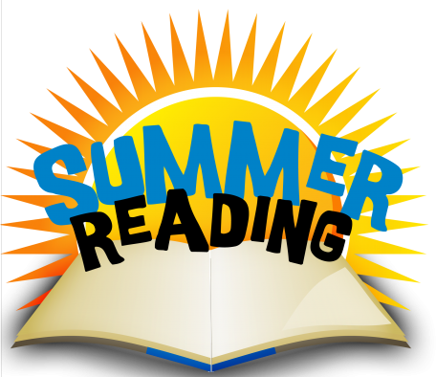
Rising 4th and 5th Graders Summer Reading Guidelines 2019
Goal: Read 20 hours this summer and log your hours on the form provided by Knox County Library. This form was sent home with Report Cards. You can also visit your local library for the form or write them on a sheet of paper.
Bring the completed form to your local library for great prizes. Request to keep the form!!!
Bring this same completed form back to school by Friday, August 9, 2019 for a reward. This will count as your first homework grade for Language Arts.
What do I read? Read books from the suggested list attached, age appropriate books of your choice, or books suggested by Knox County Library.
Find a good book and enjoy!

