1) Seraphim | The highest choir; known with their zeal and love of the Trinity; Lucifer may have been one. Shown with 6 wings and eyes; closest to God's throne; greatest intellect, love, and will; perceive God in the richest way possible for a created being; one task - to worship and adore God.
Isaiah 6:1-8  Revelation 4:8 | 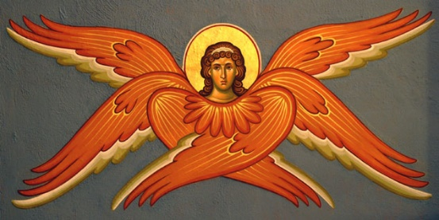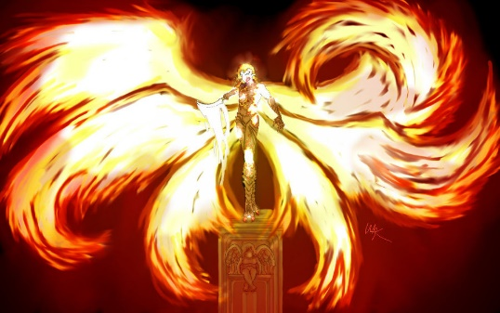
Adelaide
Tinsley
Angel
The 9 Choirs of Angels

2) Cherubim | Angels of wisdom; guardians/protectors; guarded the entrance to Eden; sat upon the Ark of the Covenant. Shown as four-eyed, blue-winged, presenting a book (knowledge); perfect vision of God and the beauty of creation.
Genesis 3:24  Exodus 25:10-22 | 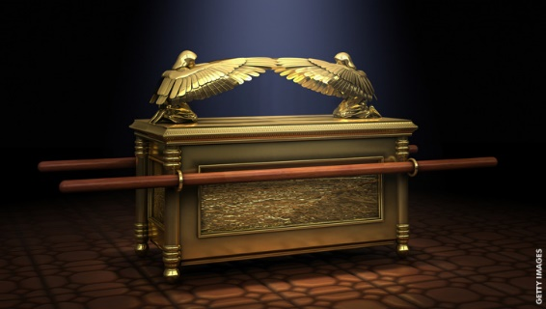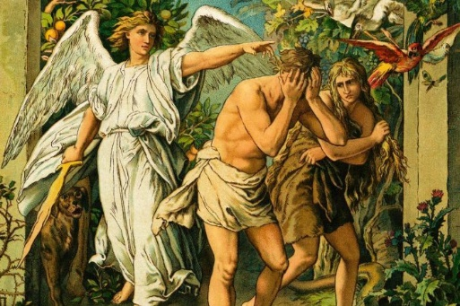
Dagan
Jaxon
Shavar

3) Thrones | Shown in a kneeling posture of adoration; through them, God accomplishes His judgments.
Colossians 1:16 | 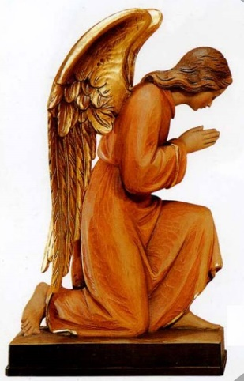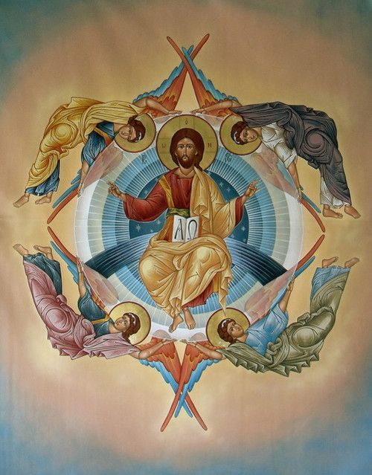
Chris
Da’siah
Elijah
Aaliyah

4) Dominions | Shown in royal robes; crowned for their authority, movers of stars and planets; direct the Virtues and Powers in their duty of governing and ordering the laws of creation.
Colossians 1:16 | 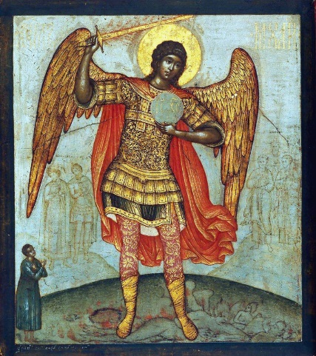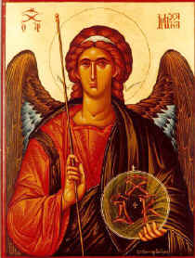
Stan
Landen
Jose

5) Virtues | Charged with dispensing celestial miracles and accomplishing stupendous works; order nature.
Matthew 2:1-12 | 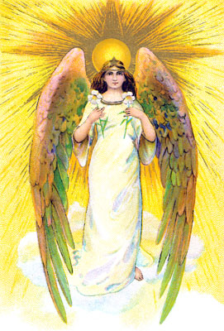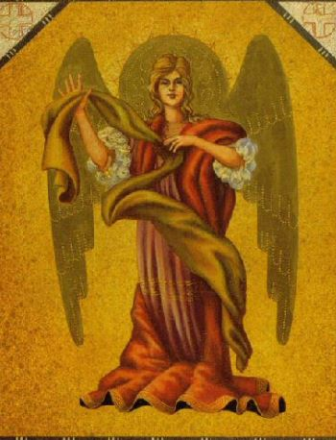
Karen
Bella
Abby

6) Powers | Shown with swords; have special abilities in restraining the assault of evil spirits; direct lower choirs.
Romans 8:38 | 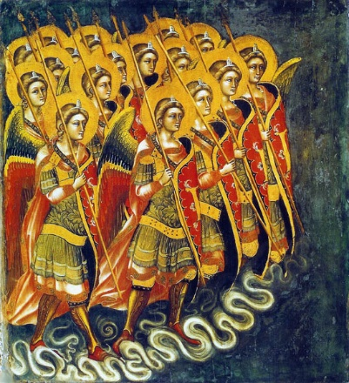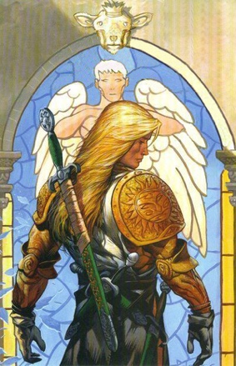
Daniel
Eddie
Jack

7) Principalities | Direct the implementation of God’s will on earth; assigned to nations; direct lower choirs.
Ephesians 3:10 | 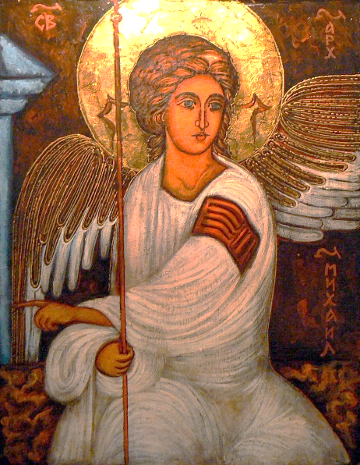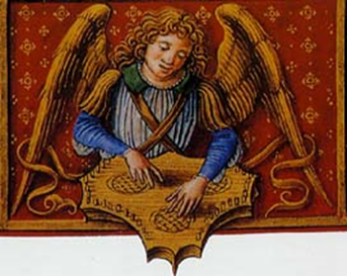
Lily
Leigh
Olivia

8) Archangels | Only named Angels in the Bible: St. Michael; St. Gabriel; St. Raphael; Possibly seven total. Messengers of God in significant matters; carry out God's commands.
Jude verse 9  Revelation 12  Luke 1:5-38  Book of Tobit | 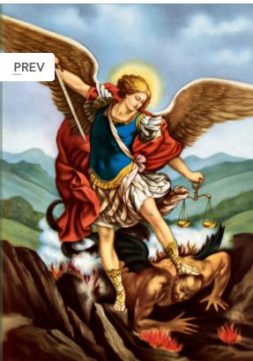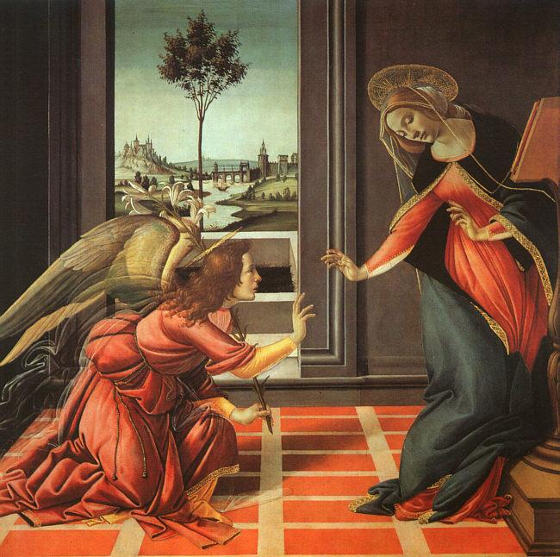
Dean
Daniel
Caroline

9) Angels | God's messengers and guardians of mankind; each human is assigned one Guardian Angel to guide him/her to God and protect from spiritual/physical harm
Genesis 18:1-29  Matthew 18:10 | 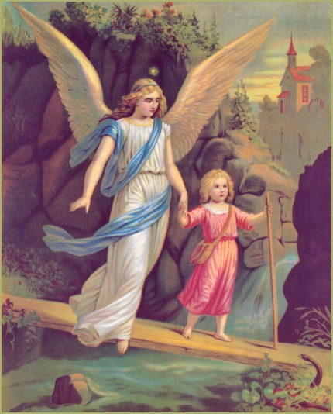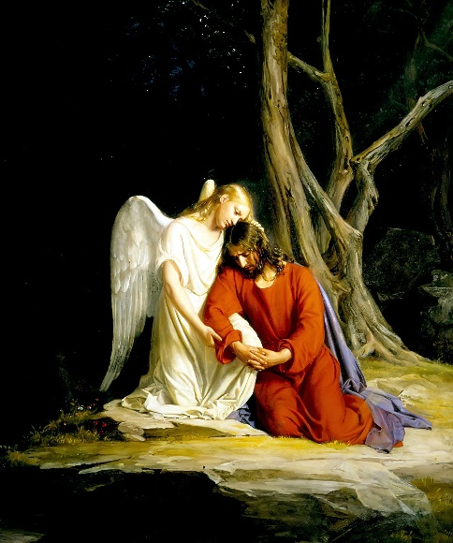
Everyone

Example: Be accurate. Follow the descriptions and picture models. Use full paper space and be colorful. Label the Choir and place scripture verses below as well. Include the angel’s name if it is known.

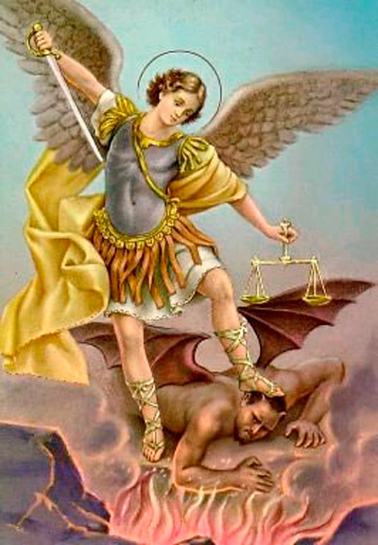
Archangel: St. Michael
Jude verse 9; Revelation 1; Luke 1:5-38

