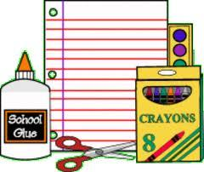
Fourth and Fifth Grade Supply List
6 Packs of #2 pre-sharpened pencils at least 10 in a package (Please no Office Depot brand)
3 package of cap erasers
1 Pair of scissors
1 Yellow Highlighter
5 Glue Sticks
1 Zippered pencil case (NO BOXES) Boxes will be returned if purchased
4 Packs of wide ruled paper
6 Vinyl pocket folders with metal prongs, in the following colors
(Red, Yellow, Orange, Blue, Purple, and Green)
1 Folder of Child’s Choice with Pockets
2 Large boxes of tissues
1 roll of paper towels
1 container of Clorox Wipes
1 Zippered Three Ring Binder with Expanding File Folder to hold all removable suject folders
2 Packages of red pens
large or XL book covers for 4th Graders and 4 large or XL book covers for 5th Graders
3 packages of index cards (white)
Boys Only Provide the Following:
- 1 medium bottle of hand sanitizer
- 1 package of Expo markers
Girls Only Provide the Following:
- 1 package of Crayola colored pencils (box of 8-12)
- 1 package of Crayola crayons (24 count)
- Frebreez Air Freshner Spray
Technology/Library Supply List
Earbuds
4th Grade 1 Package Scissors 5th Grade 1 Package of Pencils
Art Supply List
1 Container of Clorox Wipes
Spanish Supply List
1 container of Clorox Wipes
1 One Inch Three Ring Binder with 5 Subject Dividers
1 pack of wide ruled paper

