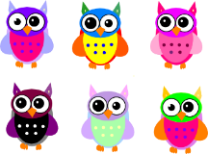
First Grade Supply List
St. Joseph School, Mrs. Sompayrac
24 pack #2 pencils
(2) 8 pack of washable markers
(4) 24 count crayola crayons
5 pack Expo dry erase markers
1 pair of fiskar scissors
(2) 5 pack of glue sticks
1 plastic red folder with prongs & pockets
1 plastic purple folder with prongs & pockets
1 folder of your child’s choice (any kind, character…)
1 box of sandwich size ziploc bags (GIRLS)
1 box of gallon size ziploc bags (BOYS)
2 boxes of tissues
1 roll of paper towels
2 containers of disinfectant wipes
1 pack of colored pencils
1 plastic pencil box (8x5)
1 ream of white copy paper
** Please label your child’s folders, pencil box, and scissors. All other supplies will be shared. Thank you!
Spanish~ 1 box of 24 color markers & 1 Purple Folder
Technology~ 1 pair of headphones for tech lab (no ear buds please) & 1 box of Tissue
Art~ 1 Container of Clorox Wipes

